Force and Pressure - 04
CLASS 08 - SCIENCE

 | Section A
1 | Assertion (A): Apple falls on the ground, due to gravitational force. Reason (R): Gravitational force is a contact force.  a) Both A and R are true and R is the correct explanation of A.  b) Both A and R are true but R is not the correct explanation of A.  c) A is true but R is false.  d) A is false but R is true. | [1]
2 | Assertion (A): When a stone is thrown vertically upward, after getting a certain height’ it comes back to the earth. Reason (R): Stone has to work against the force of friction of air.  a) Both A and R are true and R is the correct explanation of A.  b) Both A and R are true but R is not the correct explanation of A.  c) A is true but R is false.  d) A is false but R is true. | [1]
3 | Assertion (A): Steel nails are pointed at one end to have the least area of contact with the surface. Reason (R): Least area exerts high pressure.  a) Both A and R are true and R is the correct explanation of A.  b) Both A and R are true but R is not the correct explanation of A.  c) A is true but R is false.  d) A is false but R is true. | [1]
4 | Assertion (A): There is high atmospheric pressure in the space. Reason (R): Astronauts wear special suits.  a) Both A and R are true and R is the correct explanation of A.  b) Both A and R are true but R is not the correct explanation of A.  c) A is true but R is false.  d) A is false but R is true. | [1]
5 | Assertion (A): Sea divers wear special suits. Reason (R): The gravity is not affect under the sea.  a) Both A and R are true and R is the correct explanation of A.  b) Both A and R are true but R is not the correct explanation of A.  c) A is true but R is false.  d) A is false but R is true. | [1]
6 | Assertion (A): The motion imparted to objects was due to the action of a speed. Reason (R): In science, a push or a pull on an object is called a force.  a) Both A and R are true and R is the correct explanation of A.  b) Both A and R are true but R is not the correct explanation of A.  c) A is true but R is false.  d) A is false but R is true. | [1]
7 | Assertion (A): Magnetic force is a non - contact force. Reason (R): Unlike poles of a magnet attracts each other.  a) Both A and R are true and R is the correct explanation of A.  b) Both A and R are true but R is not the correct explanation of A.  c) A is true but R is false.  d) A is false but R is true. | [1]
8 | Assertion (A): When we stop pedaling a bicycle, it gradually slows down and finally comes to a rest. Reason (R): No force appears to be acting on the object yet their speed gradually decreases and they come to rest after some time.  a) Both A and R are true and R is the correct explanation of A.  b) Both A and R are true but R is not the correct explanation of A.  c) A is true but R is false.  d) A is false but R is true. | [1]
9 | Assertion (A): When we push an object like a school bag or lift a bucket of water where does the force come. Reason (R): This force is caused by the action of muscles in our body.  a) Both A and R are true and R is the correct explanation of A.  b) Both A and R are true but R is not the correct explanation of A.  c) A is true but R is false.  d) A is false but R is true. | [1]
10 | Assertion (A): While taking a penalty kick in football, the player applies a force on the ball and ball move toward the goal. Reason (R): The goalkeeper try to save the goal and therefore he apply force to stop the ball.  a) Both A and R are true and R is the correct explanation of A.  b) Both A and R are true but R is not the correct explanation of A.  c) A is true but R is false.  d) A is false but R is true. | [1]
 | Section B
11 | State True or False:  - Liquids exert pressure upwards too.  - Electrically charged comb can attract tiny pieces of paper.  - A push or a pull of an object is called force.  - SI derived unit of pressure is pascal.  - Gravity is an example of non contact force.  - The pressure of liquid decreases with depth.  - Gravity pulls everything towards itself.  - Muscular force is an example of a contact force.  - Magnetic force is an example of non contact force.  - Frictional force is a non contact force.  - Pressure is directly proportional to the area occupied by the object.  - Force can not change the speed of the moving body.  - Force has magnitude but not direction.  - High air pressure produced by the gas molecules causes it to expand.  - Liquids exert pressure on the bottom of the container.  - Pascal is the unit of force.  - If two forces act in the opposite directions, then net force is the sum of the two forces.  - Force can change the direction of the moving body.  - The force of friction opposes the motion of the body. | [19]
 | Section C
12 | Fill in the blanks:  - The north pole of a magnet ________ the north pole of another magnet.  - Force acting on per unit area is called ________.  - A ________ or a ________ on an object is called force.  - To draw water from a wellwe have to ________ at the rope.  - The pull or push is called ________.  - While the arrow moves towards its target, the forces acting on it are due to ________ and that due to ________ of air.  - To stretch the bow, the archer applies a force that cause a change in its ________.  - The wear and tear in the machine parts is due to ________.  - The type of force responsible for a change in the state of motion of the arrow is an example of a ________ force.  - The force applied by the archer to stretch the bow is an example of ________ force.  - Force acting due to the action of muscles is called ________.  - The force exerted per unit area is called ________.  - Force of friction is an example of________force.  - To move a loaded trolleywe have to ________ it.  - A charged body ________ an uncharged body towards it.  - An object’s ________ with another object results in a force between the two objects. | [16]
 | Section D
13 | Match the following: 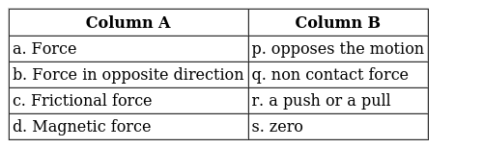 | [2]
14 | Match the following: 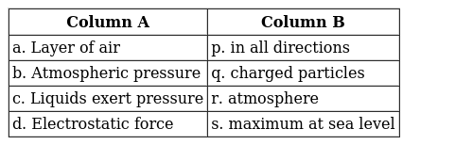 | [2]
15 | Match the following: 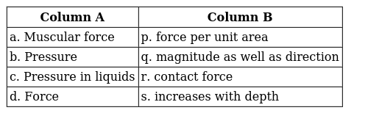 | [2]
16 | Match the following: 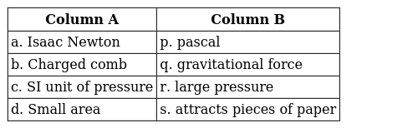 | [2]
17 | Match the following: 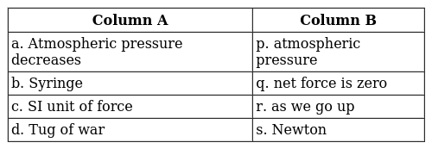 | [2]
18 | Match the items given in Column A with those in Column B suitably: 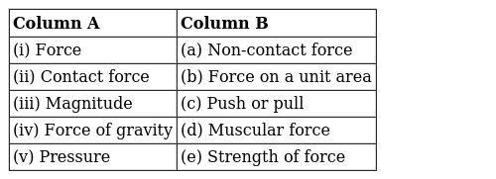 | [2]
19 | Match the items given in Column A with those in Column B suitably: 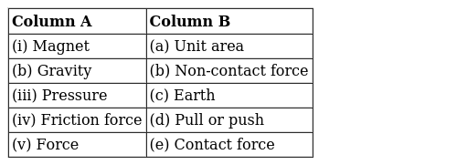 | [2]
 | Section E
20 | Define the following:  - Muscular force  - Frictional force | [3]
21 | Prove that the pressure exerted by water at the bottom of the container depends on the height of its column. | [3]
22 | Define force. Give examples of force in everyday life. | [3]
23 | Where do we apply a force while walking? | [3]
24 | Two thermocol balls held close to each other move away from each other. When they are released, name the force which might be responsible for this phenomenon. Explain. | [3]
25 | What experiment was performed to prove that air has pressure? | [3]
26 | Show that a liquid exerts pressure on the walls of the container. | [3]
27 | Write a short note on electrostatic force with examples. | [3]
28 | Fruits detached from a tree fall down due to the force of gravity. We know that a force arises due to the interaction between two objects. Name the objects interacting in this case. | [3]
29 | What are non - contact forces? Explain different types of non - contact forceswith examples. | [3]
30 | Two persons are applying forces on two opposite sides of a moving cart. The cart still moves at the same speed in the same direction. What do you infer about the magnitudes and direction of the forces applied? | [3]
31 | What are contact forces? State different types of contact forces. | [3]
32 | In the circuit shown in Fig. when the key is closed, the compass needle placed in the match box deflects. Name the force which causes this deflection. 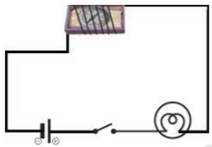 | [3]
33 | Show that the force has a magnitude as well as direction. | [3]
34 | Write a short note on magnetic force. | [3]
35 | It is much easier to burst an inflated balloon with a needle than by a finger. Explain. | [3]
36 | It is difficult to cut cloth using a pair of scissors with blunt blades. Explain. | [3]
37 | Write the effects of the force applied on an object. | [3]
38 | Fig. shows a car sticking to an electromagnet. Name the forces acting on the car? Which one of them is larger? 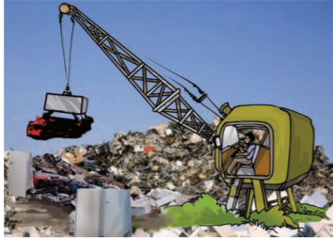 | [3]
39 | Two rods of the same weight and equal length have different thicknesses. They are held vertically on the surface of sand as shown in Fig. Which one of them will sink move? Why? 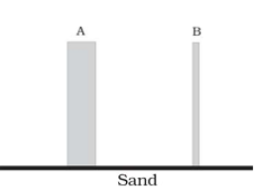 | [3]
40 | A man is pushing a cart down a slope. Suddenly the cart starts moving faster and he wants to slow it down. What should he do? | [3]
41 | Fig. shows a man with a parachute. Name the force which is responsible for his downward motion. Will he come down with the same speed without the parachute? 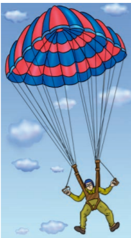 | [3]
42 | What are non - contact forces? Explain different types of non - contact forces. | [3]

